Dear _________,
I’m excited to share that I will be participating in the annual 5K Virtual Event: Let’s Move For Sickle Cell Disease. I am participating because I believe in STAR’s mission and vision; To help cure Sickle Cell Disease.
Frequent pain episodes are the hallmark of SCD but this terrible disease can also cause severe lung problems, strokes, kidney failure, and blindness. This cruel disease kills many people before the age of 40. BUT THERE IS A PROVEN CURE- bone marrow transplantation. No large organization has existed dedicated to transplant research to cure SCD.
STAR (Sickle Cell Transplant Advocacy & Research Alliance) is the only large organization with a focus solely on research to cure Sickle Cell Disease. This research is best advanced through clinical studies involving multiple institutions. STAR provides both critical funding as well as an organized collaborative network of nearly 40 pediatric hospitals across the United States and Canada in support of this important research.

To learn more about STAR and their current initiative, please click below:
https://curesicklenow.org/index.php/research-initiatives/
Insert Story Here: You can use your own personal story or reason why you are participating and supporting STAR’s 5K Event! Here’s mine!
Example:
Jayden was born with SCD SS. He suffered tremendously with this disease as his symptoms started as early as 6 months old. He required frequent blood transfusions and multiple hospital admissions. Jayden suffered from pain crises, and lung issues along with many other symptoms. When he was 2 years old, we were told that if Jayden didn’t receive a bone marrow transplant he wouldn’t survive long, and if he did his quality of life would be poor.
My husband and I did not plan on having any other children since we knew there would be a risk of having another child with SCD. We grasped onto our faith and prayed for a miracle. The prayer was answered when we learned we were pregnant, and on March 23, 2009, I gave birth to a healthy baby boy named Justin who was tested to see if he was a bone marrow match for his brother Jayden. Soon after we received the exciting news, not only was Justin a match, but he was a “perfect match” as the doctors put it. Justin donated this bone marrow and Jayden’s transplant procedure occurred on March 24, 2011, just a day after Justin’s 2nd Birthday. Unfortunately, Jayden took a turn for the worse as he suffered a stroke an hour after the transplant, but fortunately he recovered from it, and he was able to continue his journey to being 100% sickle cell free! Today 10 years after the transplant, Jayden is healthy and thriving 18 year old who lives an active pain free life!
I hope you will consider helping me for this important cause in support of STAR’s mission to help cure Sickle Cell Disease so more people can be cured like Jayden was. You can join me by being part of the cure and donating on my behalf. You can donate by clicking the link below!
https://curesicklenow.org/index.php/event/sickle-cell-disease-awareness-5k-walk-run/
Thank you for your help!
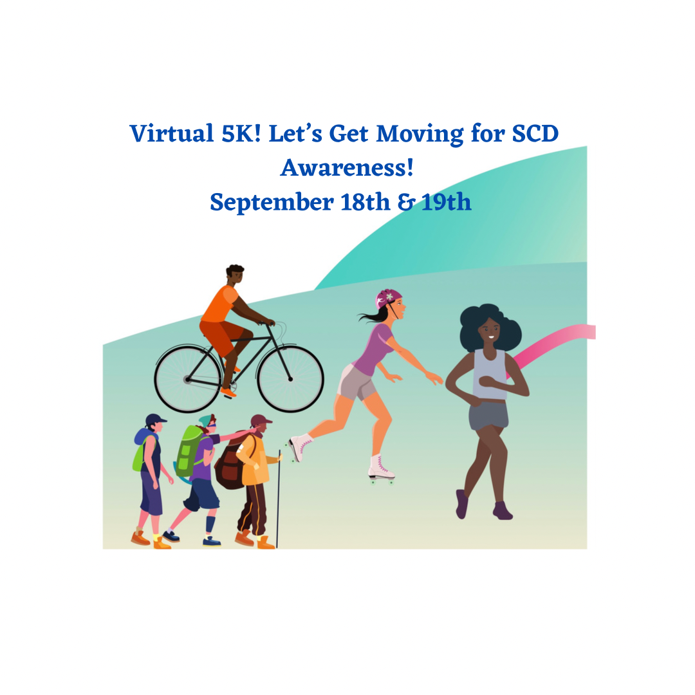

Ways To Fundraise!
Register online for the walk https://curesicklenow.org/index.php/event/sickle-cell-disease-awareness-5k-walk-run/
After you’ve registered, customize your personal fundraising page on Facebook! https://curesicklenow.org/index.php/fundraise-with-facebook/ Add a photo and your personal story. Make a donation yourself to jumpstart your fundraising and show your donors your personal commitment. Make sure you title the page: 2021 5K Virtual Event- Let’s Move For Sickle Cell Disease!
Ask all your donors to share your campaign with 10 of their friends with a request for a donation. Fundraise on Facebook!
Other ways: Email your friends, family, and co-workers our fundraising letter. Ask them to support you.
Identify one corporate sponsor that you can ask for a large donation. Offer to help with advertising in exchange by wearing a company shirt or hat during your walk!
In lieu of gifts for major life events like birthdays, retirements, anniversaries, etc., ask your friends and family to donate to through your Facebook Fundraising page.
Add a link to your STAR’S website to your email signature through your fundraising dashboard. Ask your sickle cell doctor(s) and researchers to donate to your walk fundraising page.
If you’re celebrating national holidays (Memorial Day and Fourth of July) ask everyone at your event to donate.
After the walk, host a virtual event to celebrate all the hard work you and/or your team accomplished!

